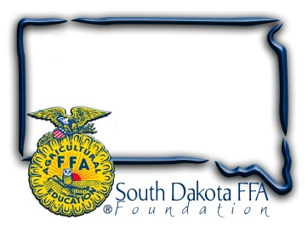
For Immediate Release
Contact: Gerri Ann Eide
605-765-4865
gerri@sdffafoundation.org
Gerri@sdffafoundation.org

For Immediate Release

SD FFA Highlights Agriculture with Ag Adventure Zone
SD FFA is highlighting agriculture in the Rodeo Zone during Rodeo Rapid City, Jan. 27-Feb. 4, 2024. The Ag Adventure Zone is sponsored by South Dakota Farmers Union as a special project of the SD FFA Foundation. “We are excited to team up with FFA to provide hands-on education about South Dakota’s number one industry,” said Karla Hofhenke, Executive Director of South Dakota Farmers Union. “The Ag Adventure Zone is a creative way for consumers to connect with what South Dakota’s family farmers, ranchers and other ag professionals do each and every day to help feed and fuel the nation.”
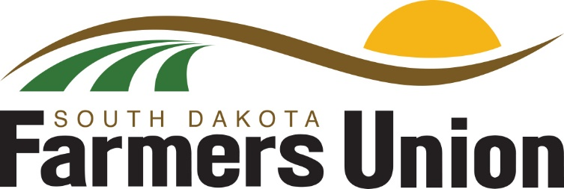
Located in the Ice Arena at The Monument, in Rapid City, the Ag Adventure Zone will illustrate the diversity of South Dakota agriculture, with interactive and educational exhibits on beef, swine, grain, and more from production to processing. The Ag Adventure Zone’s mission is to: showcases modern agricultural practices, communicates commitment to natural resources and demonstrates wholesome, safe food production for all ages. Industry volunteers, State FFA officers and District 5 FFA members will be at the Ag Adventure Zone to host activities and interact with Black Hills Stock Show attendees.

“We are extremely thankful for the support of the South Dakota Farmers Union and Sutton Rodeo to bring this important event to Rodeo Rapid City. We hope that this partnership will carry on for years to come so we can continue to educate the public about agriculture,” says South Dakota FFA Executive Secretary Wyatt DeJong.

The SD FFA is also hosting “FFA Day” on Monday, January 29th as part of Rodeo Rapid City. High school FFA members from South Dakota, Nebraska, and Wyoming will attend interactive presentations, learning from industry leaders on topics in four agriculture pathways: animal systems, plant systems, power/structural systems and advocacy/ communications. Presenters include: SD Pork Producers, SD Beef Industry Council/Wall Meats, SD Sheep Growers Association, Tyson Foods, SD Soil Health Coalition, SD Florists Association, RDO Equipment, Agtegra Innovation Center, SD Stock Growers, and NewsCenter1/Homegrown. FFA members will gain insight into current agricultural practices and innovations and ask the experts questions. Members will also have the opportunity to attend a Beginning Land Ownership & Succession Planning seminar, attend a livestock judging school, livestock judging contest, cattle shows and sales, and visit vendors.

The SD FFA Foundation is proud to support Agricultural Education and the FFA's mission to make a difference in the lives of students by developing their potential for premier leadership, personal growth and career success through agricultural education. For more information about the South Dakota FFA Foundation and South Dakota's FFA programs, visit www.sdffafoundation.org or follow us on Facebook.

###

